Project Description

1. Executive Summary

Bothered by the redundant procedures of verifying academic record in many scenarios, we propose to build an education passport system named Epass basing on blockchain technology. Combining the characteristic of trustworthy and security of blockchain technology, this system will solve the problem produced by traditional paper document. The blockchain technology create a decentralized ledger that securely store “transaction” information in a distributed method. With the development and deeply research on blockchain, the concept of smart contract is proposed in which the transaction can not only be virtual currency but also well-programmed agreement. By combining these technology, our proposed system will highly improve the efficiency in certificate handling work and provide a better way for issuing and storing academic record.

1. Background

As a proof of education experience, certificate is a form a verifying document widely used in the whole world for hundreds of years. Acted as a formal document, certificate covers plenty of aspects in education area in modern society. From the diploma for finishing junior high school to graduate certificate for doctor degree, people have to hold bunch of paper documents in their studying career. With the facilitation of modern internet technique, much of the redundant materials are not necessary since work could be done on network. However, there are still a great number of procedures when facing with the problem of certificate verification. As an example, graduate studying application progress can provide us the complexity and inconvenience of traditional education certificate documents.

Blockchain technology is a growing area of interest for many organizations, companies and universities. Blockchain technology create a decentralized environment in which most of the data on the blockchain is visible to all its participants. Besides, based on consensus mechanism, blockchain technology can make sure that any record (block named in blockchain technique) on the blockchain is trustworthy and hardly can anyone cheat on any record. As we could imagine, if blockchain technology could be paved as the infrastructure for education record, procedure of certificate verification could be highly limited. Not only used for education background verification but also some more convenient usage could be created, such as for employment.

1. Objectives

In this research, we propose to analyze and build an “Education Passport” system (shorten as Epass) basing on blockchain technology. The Epass system works as a public education record on the blockchain. Any organizations could verify the authenticity of someone’s education background from the blockchain and they may trace back to the very beginning of education history. The education record on the blockchain is trustworthy since it will be verified before added to the blockchain.

For individuals, any education experience will be certificated and record on the blockchain. The education experience certifying is not limited to long term studying such as graduating from undergraduate studying. It could be appropriate for wider range like finishing project for a university professor or receiving a certificate from online course.

For organization, verifying authenticity of individual’s academic record is simple to be accomplished. Even if the organization providing the certificate doesn’t exist anymore, people can still finish the checking process since the data is not just store in centralized server.

1. Similar Work

Similar work is in progress by many companies and universities.

Sony Corporation and Sony Global Education, which is the subsidiaries of Sony company, developed the technology that securely transmit data between two specific part such as academic proficiency records. With the accomplishment of such infrastructure basing on blockchain, any evaluating organization could access to the test result of individuals. That will greatly reduce the work of certifying and emailing paper documents.

The Joint Research Centre (JRC) of European Commission use the concept self-sovereign identity of blockchain, meaning that individuals store their own identity as a token on personal device. Certifications are transferred on the blockchain as a currency when one issue a certificate to another. When considering the growth in size of blockchain, they propose to build the system on private or permissioned chain. Besides, the concept of blockcert proposed by MIT media laboratory, is combined into to the system for dealing with issuing and verification problem.

As a pilot program developed by Dubai, Educhain is based on the concept of academic passport. People can then view, manage, and share academic record for school transfers, university applications, and job applications. Academic institutions can issue digital credentials, cutting processing time and costs while placing ownership of academic records into the hands of students and providing them with global mobility

1. User Case

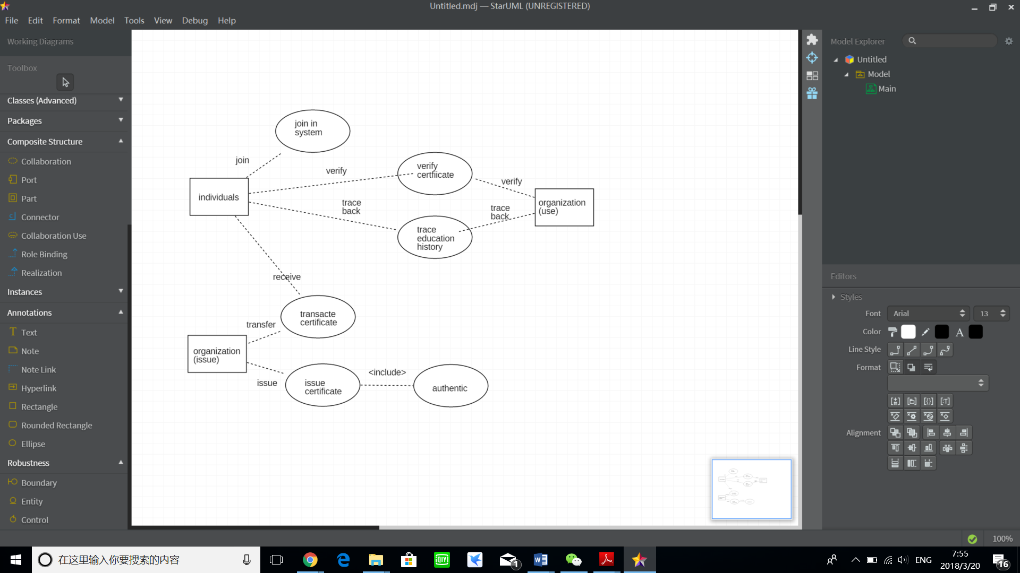

1. Problem to be solved

A few problems need to be solved in this project.

1. How can we define issuing certificates by organization? If we define the certificates as currency, how can organizations or individuals get the currency for transacting.
2. How to solve the problem of mining? Build the blockchain on the private chain?
3. How to solve the problem of the current high costs and energy wastefulness of the process of mining. Data writing is extremely slow.
4. Etherium can handle 20-30 transactions per second. If all the organization issue certificates to individuals together, how can we guarantee the efficiency.
5. Entity Relationship

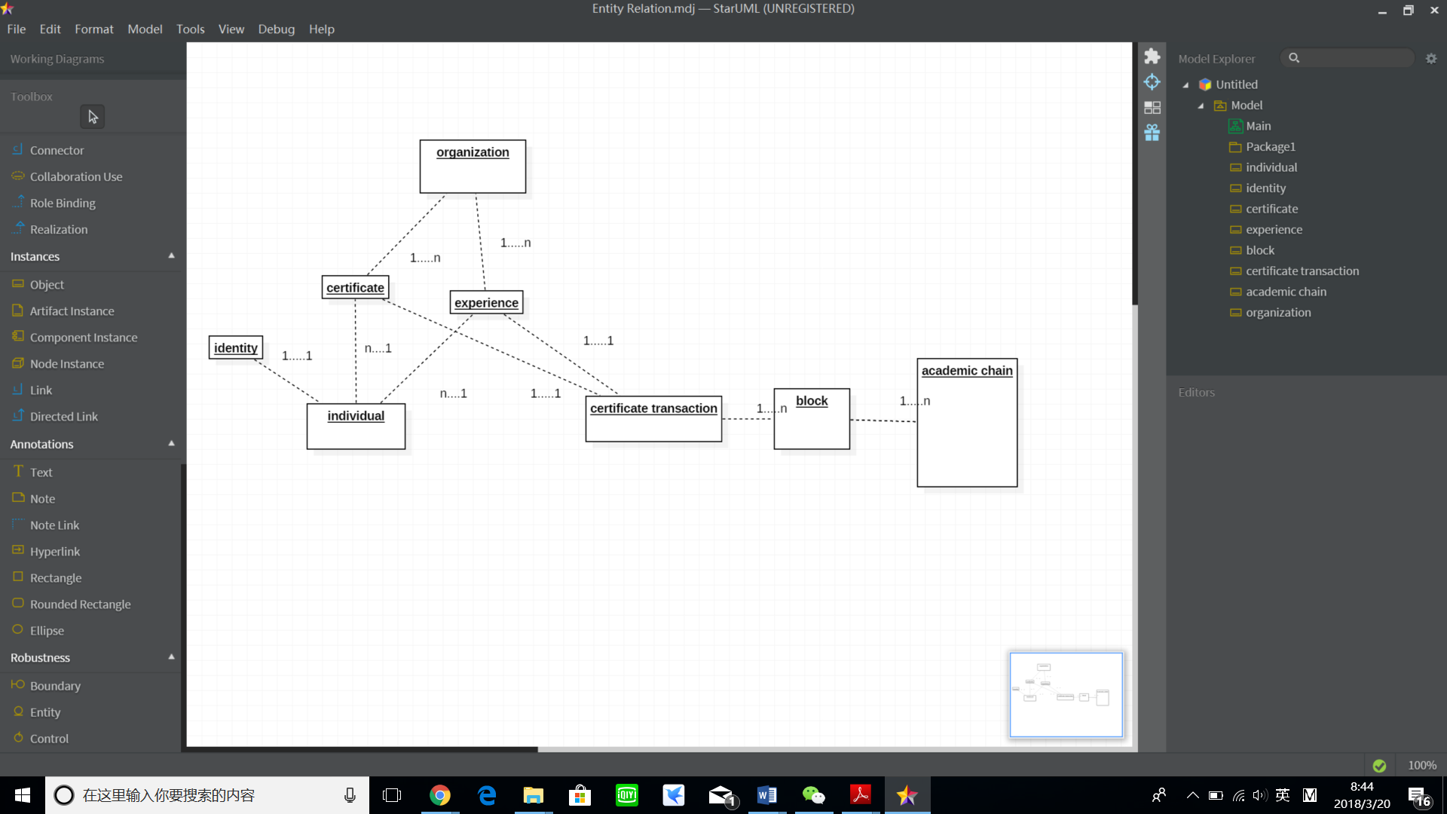

1. Time schedule

（primary design）

